

SEMESTER 2 EXAMINATION 2009/2010

Data Structures and Algorithms II

COMP20040 - SOLUTIONS

Prof. M Mc Ginnity
Prof. J. Carthy
Dr. R. Collier*

Time allowed: 2 hours

Instructions for candidates

Answer question one and one other question

1. Answer parts (a) to (e). 50 marks in total

- What is a tree? List the operations that are typically associated with this Abstract Data Type. Provide a brief description of each operation.
(13 marks).

Definition (2 marks)
A Tree is a hierarchical ADT where data is related in terms of parent-child relationships.
  - Each element (node) in the tree has at most 1 parent.
  - Each element (node) may have 0 or more children.
  - Each tree will include exactly one element (node), known as the root, which has no parent.

Operations (11 marks):
  - root() returns the Position for the root
  - parent(p) returns the Position of p’s parent
  - children(p) returns an Iterator of the Positions of p’s children
  - isInternal(p) does p have children?
  - isExternal(p) is p a leaf?
  - isRoot(p) is p==root()?
  - size() number of nodes
  - isEmpty() tests whether or not the tree is empty
  - iterator() returns an Iterator of every element in the tree
  - positions() returns an Iterator of every Position in the tree
  - replace(p, e) replaces the element at Position p with e

- What is a binary tree? Describe the following types of binary tree: proper, improper, and complete. Illustrate each description with a diagram of a corresponding binary tree.
(12 marks).

Definition (3 marks):
A Binary Tree is a tree with the following properties:
  - Every node has at most 2 children (degree 2)
  - Each child node is labelled as being either a left child or a right child
  - A left child precedes a right child in the ordering of children of a node

Proper Binary Tree (1 mark + 2 for diagram): a Binary Tree in which all nodes have degree 0 or 2.

Improper Binary Tree (1 mark + 2 for diagram): a Binary Tree in which all nodes have degree 0, 1or 2.

- Complete Binary Tree (1 mark + 2 for diagram): a Binary Tree T, with height h, is complete if:
  - Levels 0 to h-1 have the maximum number of nodes possible
  - In level h-1, all the internal nodes are to the left of the external nodes, and there is at most one node that has only a left child.

- Explain how you would implement a link-based binary tree. In your answer, describe the internal structure of a node, identify what key data you must keep track of, and illustrate your description with a diagram of an example tree that contains three nodes.
(10 marks).

Talk around the following diagram:
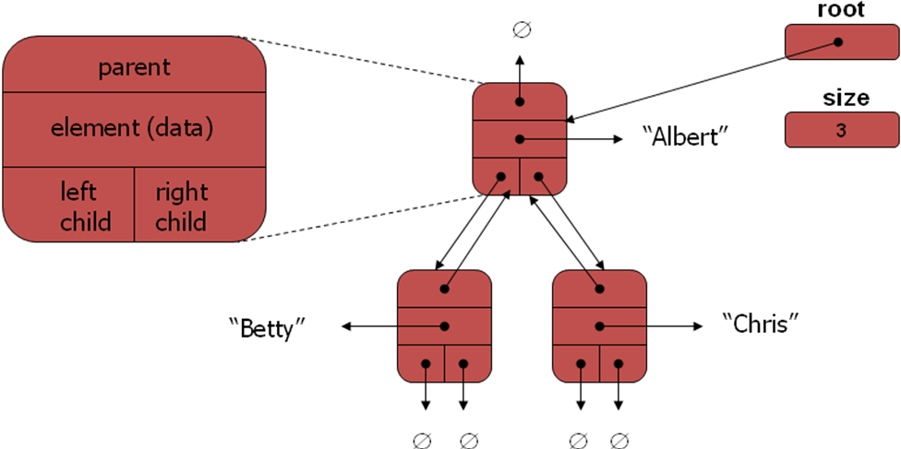

- One application of binary trees is a heap. Heaps make use of two key properties: the order and structural completeness properties. Give definitions for each of these properties.
- marks).
Order Property: key(parent) ≤ key(child)
Structural “Completeness” Property: all levels are full, except the bottom, which is “left-filled”

- Describe the steps by which items are removed from a heap. Illustrate your answer by removing an item from the following heap.
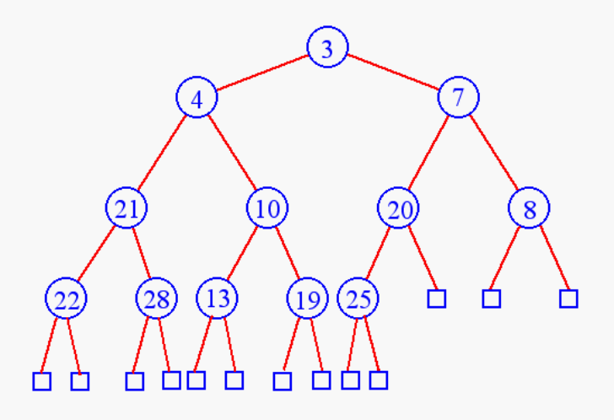
Removing from a Heap (8 marks + 3 marks for solving the problem):
  - Remove the root node (this is the current min entry).
  - Replace this node with the last item in the heap, node L.
  - Perform a Downheap to re-establish the “ordering property”. This involves checking whether L is less that its children. If it is not, then L is swapped with the smaller of the two children, and downheap is performed again on L in its new position.
  - Update the “last” reference. Need to do an inverse pre-order traversal (I.e. goto the node that is before the last node in a pre-order traversal). If there is no previous node, then find the last node on the next level up.
(11 marks).

2. Answer parts (a) to (e). 50 marks in total

- What is a binary search tree? Illustrate your answer by drawing the binary search tree that would be obtained after the following items has been inserted in the given order:

25, 31, 5, 7, 1, 33, 26
(10 marks).
Definition (3 marks):

A binary search tree is a tree that satisfies the following properties:

Let u, v, and w be three nodes such that u is in the left subtree of v and w is in the right subtree of v. We have:

key(u) ≤ key(v) ≤ key(w)

Solution (7 marks):
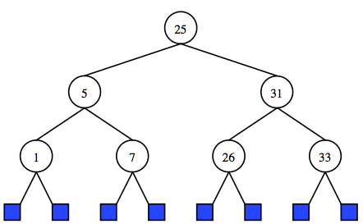

- AVL Trees are an extension of binary search trees that enforce a height-balance property. Define this property. Give an example of an AVL tree that satisfies this property and an example of an AVL tree that does not.
(8 marks).
Definition (2 marks + 3 marks for each tree):
height-balance property: For every internal node v of T, the heights of the children of v can differ by at most 1.

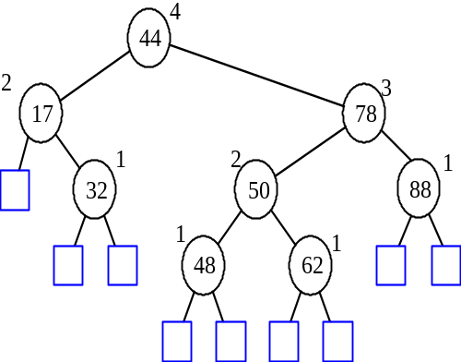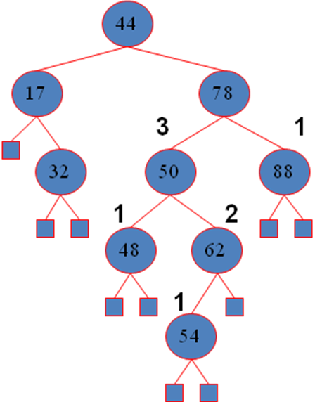
Balanced Tree Unbalanced Tree

- Explain how an unbalanced sub-tree of an AVL tree is restructured. Include in your answer the following:
  - Describe the four rotational transformations and the conditions under which they should be used.

Rotations (3 marks per rotation):
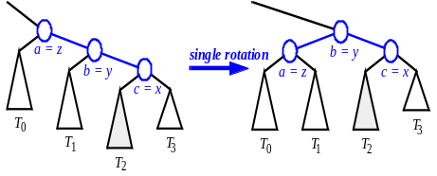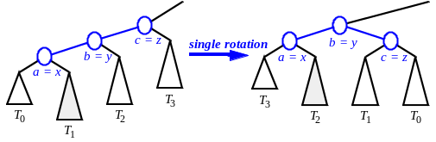
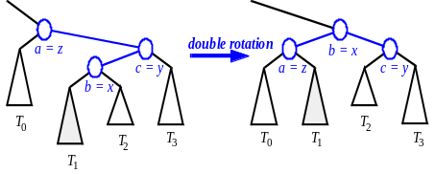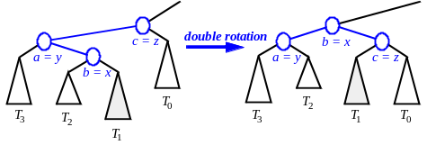

  - Describe the rebalancing algorithm that is used to ensure that the AVL tree is balanced.

Algorithm (4 marks) – from notes

(16 marks).

- Create the AVL tree that results from inserting the following items in the order given:

25, 31, 5, 7, 1, 33, 26

Using diagrams show the state of the AVL tree after each insertion.
(7 marks).

- Prove that the height of an AVL tree is O(log n)

Proof:
Let us bound n(h): the minimum number of internal nodes of an AVL tree of height h.

By inspection of example AVL trees, we can easily see that n(1) = 1 and n(2) = 2.

For h > 2, an AVL tree of height h contains the root node, one AVL subtree of height h-1 and another of height h-2. That is:

n(h) = 1 + n(h-1) + n(h-2)

Because our equation for n is a strictly increasing function of h, we also know that:

n(h-1) > n(h-2)

Hence, by replacing n(h-1) with n(h-2) we get:

n(h) > 2 . n(h-2)

And it then follows that:

n(h) > 4n(h-4),
n(h) > 8n(h-6),
…,
n(h) > 2i. n(h-2i)

But, we can solve this for a base case - we know the values for n(1) and n(2).

So, lets consider the case of n(2), hence we assume that:

h – 2i = 2

This, in turn, means that:

i = (h/2) – 1

Plugging our value of i into the inequality for n(h) gives us:

n(h) > 2(h/2)-1. n (h – 2 . ( (h/2) – 1 ) )
n(h) > 2(h/2)-1. n (h – 2 (h/2) + 2 )
n(h) > 2 (h/2)

Taking logarithms:
log n(h) > log ( 2 (h/2) )
log n(h) > h/2
h < 2. log n(h)

Thus the height of an AVL tree is O(log n)
(9 marks).

3. Answer parts (a) to (e). 50 marks in total

- Describe the key concepts that are associated with the pattern-matching problem.

Discuss the following…
- A string is a sequence of characters.
- An alphabet Σ is the set of possible characters for a family of Strings.
- Let P be a string of size m
  - A substring P[i…j] of P is the substring of P consisting of the characters with ranks in the range [i, j).
  - A prefix of P is a substring of the type P[0…i]
  - A suffix of P is a substring of the type P[i…m-1].
- Given strings T (text) and P (pattern), the pattern matching problem consists of finding a substring of T equal to P.
(4 marks)

- The Boyer-Moore algorithm is a well-known pattern-matching algorithm. Describe how this algorithm works. Include in your answer definitions of the two key heuristics that underpin the design of the algorithm.

Looking-glass heuristic: Compare P with a subsequence of T moving backwards

Character-jump heuristic: When a mismatch occurs at T[i] = c
If P contains c, shift P to align the last occurrence of c in P with T[i]
Else, shift P to align P[0] with T[i + 1]

To implement this algorithm the pattern P is preprocessed together with the alphabet S to build the last-occurrence function L mapping S to integers, where L(c) is defined as the largest index i such that P[i] = c or -1 if no such index exists.
(10 marks)

- Use the Boyer-Moore algorithm to find the first occurrence of the pattern “rithm” in the text “a pattern matching algorithm”. Start by creating the last occurrence function for the pattern, and then show how this function is used to match the pattern to the text.

c | a | b | c | d
L(c) | 4 | 5 | 3 | -1

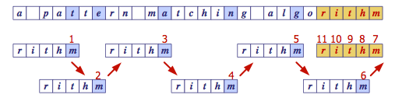
(10 marks)

- What is a graph? Give definitions of the following graph concepts: incident edges, adjacent vertices, degree of a vertex, paths, and cycles.

Graph Definition (3 marks + 2 marks per concept):
A graph is a pair (V, E), where
  - V is a set of nodes, called vertices
  - E is a collection of pairs of vertices, called edges
  - Vertices and edges are positions and store elements

Incident Edges: The set of edges that are linked to a given vertex
Adjacent Vertices: The set of vertices at the opposite end of the incident edges of a vertex.
Degree of a vertex: The number of incident edges
Path: a sequence of alternating vertices and edges that begins and ends with a vertex, and where each edge is preceded and followed by its endpoints.
Cycle: a path that starts and finishes at the same vertex
(13 marks)

- An important category of graph that is useful in task scheduling applications is known as a directed acyclic graph (DAG). DAGs are useful because they can be topologically ordered. Give the topological ordering pseudo code that was covered in this course and use it to identify a topological ordering for the following DAG.

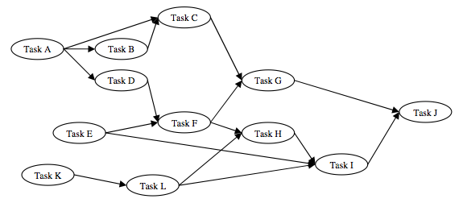

Topological Ordering Pseudo Code (7 marks):

Algorithm TopologicalSort(G)
H ← G // Temporary copy of G
n ← G.numVertices()
while H is not empty do
Let v be a vertex with no outgoing edges
Label v ← n
n ← n – 1
Remove v from H

Possible Topological Ordering (6 marks):
12 = J, 11 = G, 10 = I, 9 = C, 8 = H, 7 = B, 6 = F, 5 = L, 4 = D, 3 = E, 2 = K, 1 = A
(13 marks)

4. Answer parts (a) to (d). 50 marks in total

- Merge Sort and Quick Sort are examples of sorting algorithms that are based upon an algorithmic design pattern called divide-and-conquer. Describe this design pattern, and use it to outline the main steps involved in both the Merge Sort and Quick Sort algorithms.

Divide-and conquer
General algorithm design paradigm:
• Divide: divide the input data S in two disjoint subsets S1 and S2
• Recur: solve the subproblems associated with S1 and S2
• Conquer: combine the solutions for S1 and S2 into a solution for S

The base case for the recursive step is a sub-problem of size 0 or 1
(4 marks)

Merge Sort:
Take an input sequence S with n elements consists of three steps:
• Divide: partition S into two sequences S1 and S2 of about n/2 elements each
• Recur: recursively sort S1 and S2
• Conquer: merge S1 and S2 into a unique sorted sequence
(3 marks)

Quick-sort:
Randomized sorting algorithm:
• Divide: pick a random element x (called pivot) and partition S into
o L elements less than x
o E elements equal x
o G elements greater than x
• Recur: sort L and G
• Conquer: join L, E and G
(3 marks)
(10 marks)

- The key operation of the Merge Sort algorithm is the merge operation. Give the pseudo code for both this operation and the overall merge sort algorithm.

Algorithm merge(A, B)
Input sequences A and B with n/2 elements each
Output sorted sequence of A ∪ B
S ← empty sequence
while ¬A.isEmpty() ∧ ¬B.isEmpty()
if A.first().element() < B.first().element()
S.insertLast(A.remove(A.first()))
else
S.insertLast(B.remove(B.first()))
while ¬A.isEmpty() S.insertLast(A.remove(A.first()))
while ¬B.isEmpty() S.insertLast(B.remove(B.first()))
return S
(5 marks)

Algorithm mergeSort(S, C)
Input sequence S with n elements, comparator C
Output sequence S sorted according to C
if S.size() > 1
(S1, S2) ← partition(S, n/2)
mergeSort(S1, C)
mergeSort(S2, C)
S ← merge(S1, S2)
(4 marks)
(10 marks)

- The key operation of the Quick Sort algorithm is the partition operation. Give the pseudo code for this operation. Illustrate, using a quick sort tree, how the quick sort algorithm would sort the following items:
31, 21, 1, 4, 8, 22, 13, 44, 10, 28

Algorithm partition(S, p)
Input sequence S, position p of pivot
Output subsequences L, E, G of the
elements of S less than, equal to,
or greater than the pivot, resp.
L, E, G ← empty sequences
x ← S.remove(p)
while ¬S.isEmpty()
y ← S.remove(S.first())
if y < x
L.insertLast(y)
else if y = x
E.insertLast(y)
else { y > x }
G.insertLast(y)
return L, E, G
(6 marks)
22, 7, 9, 11, 13, 2, 19, 33, 1, 11 -> 1, 2, 7, 9, 11, 11, 13, 19, 22, 33
7, 9, 11, 2, 1, 11 ->1, 2, 7, 9, 11, 11
22, 19, 33 -> 19, 22, 33
7, 9, 2, 1 ->1, 2, 7, 9
22 -> 22
33 -> 33
2, 1 -> 1, 2
9 -> 9
1 -> 1

(8 marks)
(14 marks)

- What is a recurrence relation? Use recurrence relations to prove that the worst case running time of Merge Sort is O(n log n) and Quick Sort is O(n²) when sorting a sequence of n items.

A recurrence relation is an equation that is defined in terms of itself, e.g. n(x)=n(x-1)+1.
(2 marks)

Merge Sort Running Time:
Let T(n) be the worst case running time of merge sort to sort n numbers. The time taken to sort 1 number T(1) is 1. In general,

T(n) = Divide_time + Conquer_time + Merge Time
= O(1) + 2T(n/2) + O(n)
≤ 2T(n/2) + k.n
≤ 2(2T(n/4) + k.n/2) + k.n
≤ 4T(n/4) + 2k.n
≤ 2iT(n/2^{i}) + i.k.n

Solve for base case:
n/2^{i} = 1, i = log n

This means:
T(n) ≤ n.T(1) + k.n.log n
≤ a.n + k.n.log n, which is O(n log n)
(7 marks)

Quick Sort Running Time:
Let T(n) be the worst case running time of merge sort to sort n numbers. Time taken to sort a list size 1 T(1) is 1. In general,

T(n) = Pivot_select_time + Partition_time + Partition_lists_sorting_time
= O(1) + O(n) + T(i) + T(n – i – 1)
≤ k.n + T(i) + T(n – i – 1)

In the worst case, i is always 0

T(n) ≤ k.n + T(0) + T(n – 1)
≤ k.n + T(n – 1)
≤ k.n + k(n-1) + T(n – 2)
≤ k.n + k.(n - 1) + k.(n - 2) + T(n – 3)
…
≤ T(1) + k.(n + (n – 1) + (n – 2) + … + 2)
≤ T(1) + k. [ (n+2)(n-1)/2 ], which is O( n² )

(7 marks)
(16 marks)

